SOCS Comparison Practice: S-M Ratios in Europe and North America
Show all your work. Indicate clearly the methods you use, because you will be graded on the correctness of your methods as well as on the accuracy of your results and explanation.
A multinational corporation calculates the sales-to-marketing personnel ratio (S-M ratio), defined as the number of salespeople per marketing employee, for each of its branches. The histograms show the S-M ratios for the 52 branches in Europe and the 48 branches in North America during the 2025 fiscal year.
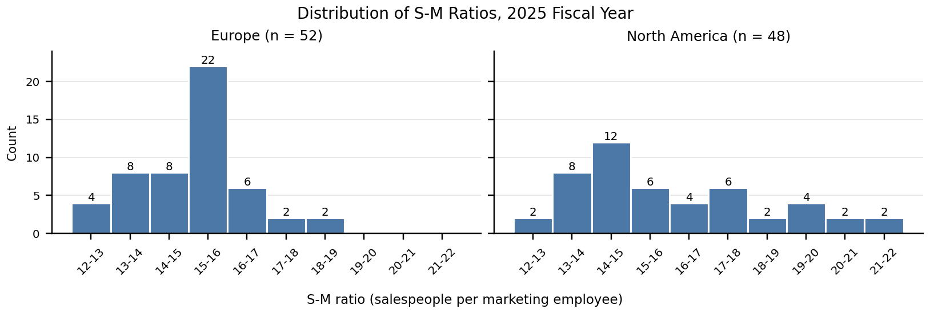
Region | n | Mean | SD | Min | Q1 | Median | Q3 | Max
Europe | 52 | 15.12 | 1.37 | 12.3 | 14.2 | 15.3 | 15.9 | 18.3
North America | 48 | 16.06 | 2.36 | 12.6 | 14.4 | 15.3 | 17.1 | 21.8
Summary statistics are calculated from the raw data. Extreme values: Europe — two smallest 12.3, 12.5; two largest 18.1, 18.3. North America — two smallest 12.6, 12.9; three largest 20.6, 21.3, 21.8.
Task (20 points): Compare the distributions of S-M ratios for the branches in Europe and North America. Address shape, outliers, center, and spread, justify your answers with appropriate calculations, and interpret your results in context.

Comparison Checklist  Shape: Describe the shape of each distribution (peaks; symmetric or skewed). State how the two shapes differ. Give evidence.  Outliers: Use the 1.5 × IQR rule to find the fences for each region. Check the extreme values. Which region has outliers, and which values?  Center: Choose the better measure and explain why. Report it for both regions and compare. Do the means tell the same story? Why or why not?  Spread: Choose the better measure and explain why. Report it for both regions and compare. Describe the middle 50% in each region.  Context: Name both groups. Use units. Explain what the comparison means for the branches. |  | Toolbox  IQR = Q3 − Q1  Upper fence = Q3 + 1.5 × IQR  Lower fence = Q1 − 1.5 × IQR  An outlier is a value beyond a fence. With skewness or outliers, compare medians and IQRs.  Phrase Bank  Both distributions are …  Europe is …, while North America is …  Unlike Europe, North America …  The medians are the same (… vs. …).  … is more variable than …  The IQR for … is larger than …  … has … outliers, but … has none.

